Study finds climate is major factor affecting upper Great Lakes’ Levels

Source: International Joint Commission Focus Spring 2010 Volume 35, Issue 1
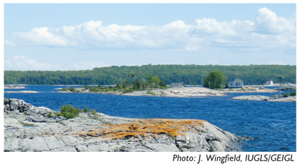
"Overall, we find the analyses, results and conclusions to be technically sound and consistent with the
Study objectives.” Independent peer reviewer co-leads (August, 2009)

Since 2007, a binational team of scientists, with extensive public input, have been investigating whether there are ongoing changes in the St. Clair River that might be affecting water levels in the upper Great Lakes. In a report released in December 2009, the International Upper Great Lakes Study Board found that:

- There has been no significant erosion in the upper reach of the St. Clair River bed since at least 2000;
- An increase in the river’s conveyance capacity accounts for some decline in head difference between Lake Michigan-Huron and Lake Erie, however, this change is not ongoing and the conveyance capacity has decreased slightly since 2000; and
- Climate is the main driver of lake level relationships over time and accounts for more of the decline in head difference.

As directed by the International Joint Commission, the Study Board also reviewed previously-proposed remedial works and new innovative approaches to modifying flows in the St. Clair River and identified a range of options that might be employed if remediation were deemed necessary. However, given that the change in conveyance capacity is within the range of measurement accuracy and appears to have reversed, the Study Board did not recommend remedial measures in the St. Clair River at this time. It did recommend that the governments of Canada and the United States undertake cooperative efforts to improve the monitoring and analysis of Great Lakes water supplies and connecting channel flows.

Throughout the Study, both methodological plans and technical work products have been reviewed by independent experts chosen by the American Society of Civil Engineers and the Canadian Water Resources Association. These expert reviewers gave generally high ratings and provided many constructive recommendations that have resulted in improvements to the report, ranging from the need for additional analysis to the need to quantify scientific uncertainty.

The IJC has announced it will hold its own public hearings on this report in the spring of 2010 so that the public has ample time to review the report, related technical studies and independent peer reviews. Since 2007, the Study has held 34 public meetings throughout the upper Great Lakes basin, including 17 meetings during a 90- day consultation period following release of a draft report on May 1, 2009.
The examination of the St. Clair River is part of a broader five-year study of the Great Lakes upstream from Niagara Falls. The study is expected to produce recommendations in 2012 on whether it is possible to improve the regulation of Lake Superior outflows through the compensating works and power dams on the St. Marys River in Sault Ste. Marie, Michigan and Ontario to take into consideration changing interests and changing climate. The report also recommends that this next phase of the study examine whether mitigation measures in the St. Clair River might be necessary based on the Study Board’s assessment of the potential future impacts of climate change on levels in the upper Great Lakes.

Copies of the report are available from the IJC offices or online at: www.iugls.org.

